* **Activity 10:**

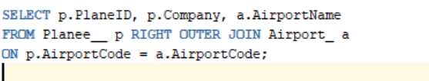Retrieving Data Using RIGHT OUTER JOIN

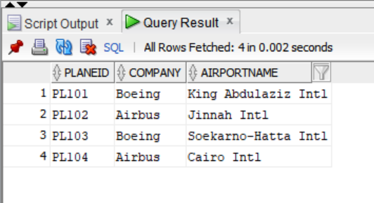OUTPUT: